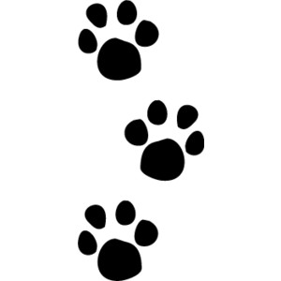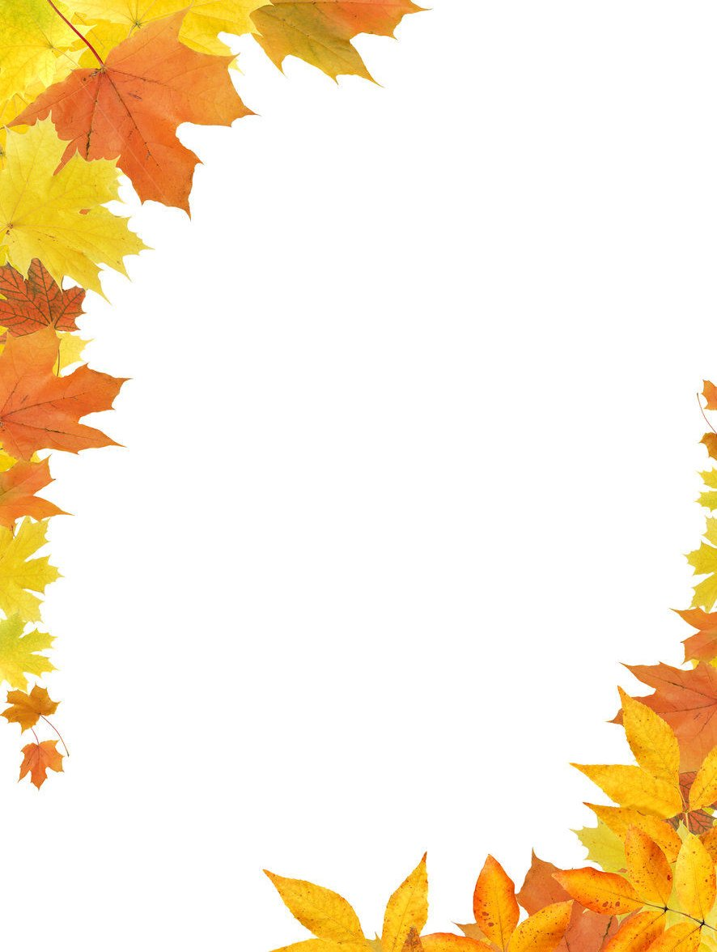

Saturday, October 26  
12:30-3:30pm

Lake Lavon Animal Hospital

Visit us at: LakeLavonAnimalHospital.com

456 N. Country Club Rd. #110 Wylie, Texas  
 (At the corner of FM 1378 and Brown Street)

(972) 429-7901

**Raffle prizes:**

* Free wellness lab screen *($163 value)*
* 6 month supply flea treatment *($81 value)*
* Premium Pet food *(value up to $80)*
* Premium Dental Chews *($40 value)*

**Events and Services:**

* $35 microchip special *($15 off) ONE DAY ONLY!*
* FREE pet tag with engraving
* FREE pet photography session

Only 8 time slots available between 1:30-3:15pm

**Call to reserve your spot.**

* Pet Training presentation
* Wylie Animal Shelter presentation
* Food and refreshments provided

Take a hospital tour and meet Dr. Lamping and his staff

**Open House**